Project Design Phase-II
Data Flow Diagram & User Stories

Date | 29 September 2026
Team ID | SWTID-2026-1757
Project Name | AI Study Buddy
Maximum Marks | 4 Marks

Data Flow Diagrams:
A Data Flow Diagram (DFD) represents how data moves through the AI StudyBuddy system. It shows how students provide information to the system, how the system processes the data, where the data is stored, and how the results are returned to the student.

Example: (Simplified)

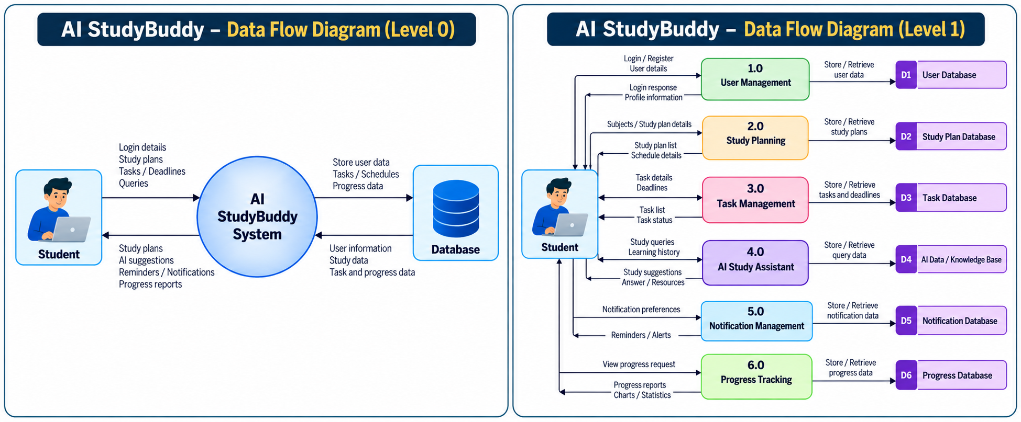

User Stories:

User Type | Functional Requirement (Epic) | User Story Number | User Story / Task | Acceptance Criteria | Priority | Release
Student (Mobile/Web User) | Registration | USN-1 | As a student, I can register for the application using my name, email, and password. | I can successfully create an account and access the dashboard. | High | Sprint-1
Student (Mobile/Web User) | Registration | USN-2 | As a student, I can verify my email after registration. | I receive a confirmation email and can verify my account. | High | Sprint-1
Student (Mobile/Web User) | Login | USN-3 | As a student, I can log in using my email and password. | Valid credentials allow me to access my dashboard. | High | Sprint-1
Student (Mobile/Web User) | Login | USN-4 | As a student, I can reset my password if I forget it. | I can request a password reset and create a new password. | Medium | Sprint-1
Student (Mobile/Web User) | Dashboard | USN-5 | As a student, I can view my study dashboard. | Dashboard displays today's tasks, upcoming deadlines, and study progress. | High | Sprint-1
Student (Mobile/Web User) | Study Planning | USN-6 | As a student, I can create a daily or weekly study plan. | I can add subjects, study time, and planned activities. | High | Sprint-2
Student (Mobile/Web User) | Study Planning | USN-7 | As a student, I can edit or delete my study plan. | Changes are saved and reflected on the dashboard. | Medium | Sprint-2
Student (Mobile/Web User) | Task Management | USN-8 | As a student, I can add assignments, projects, and study tasks. | I can enter task title, description, date, and deadline. | High | Sprint-2
Student (Mobile/Web User) | Task Management | USN-9 | As a student, I can mark a task as completed. | Completed tasks are updated with a completed status. | High | Sprint-2
Student

